SWIMMING HANDBOOK
www.abbotsleighswimclub.org.au

aquaticcentre@abbotsleigh.nsw.edu.au
Phone 02 9473 7830.

Dear Parents,
Welcome! The network of people you and your child will meet could very well become lifelong friends. We believe that these friendships along with the fact that your child will be learning life skills and gaining a high level of fitness makes swimming the best youth sport in the world. Your child will continue to reap the benefits of swimming long after their participation ends.

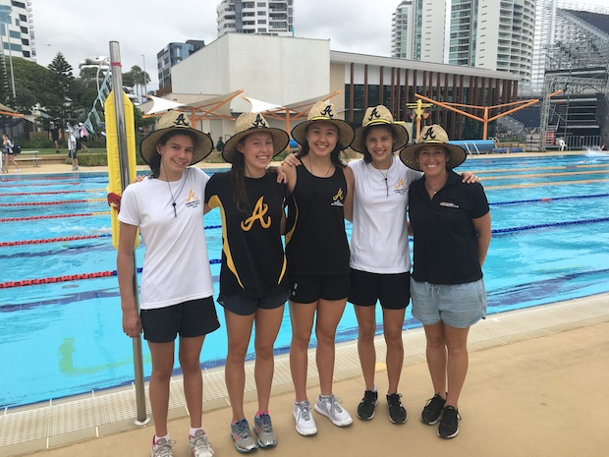

This Parents’ Handbook includes important information on how to be a supportive swimming parent, as well as general information about the sport and how you can get involved as a volunteer to support your child and the entire team.
This publication has been created to help educate you on how to support your child throughout his or her swimming career. Research has been conducted about why kids choose to participate in swimming and what makes it fun. Supportive parents play a very significant role in why kids swim, as well as why kids quit.
This booklet will also provide an overview of some of the rules of the sport. It is not substitute for the Swimming Australia Rules and Regulations book, but will give you some general guidelines of what is expected of your children from a technical standpoint.
Finally, this handbook outlines volunteer jobs within Abbotsleigh Swimming Club and Metro North East Swimming Association. We are a volunteer organisation and rely on our members giving their time to enable our children to have the best possible environment to enjoy themselves. Please read this section and then speak to an Abbotsleigh Swimming Club Committee member to find out how you can best help the club.

FOREWORD
By joining Abbotsleigh Swimming Club, your child has become a member of Australia’s rich history of swimming in this nation. Swimming has always been synonymous with Australia and has long been a back bone of physical fitness within the Australian culture. This handbook will acquaint you with the sport of swimming and introduce you to the organization of Abbotsleigh Swimming Club, Swimming Metro North East, Swimming NSW and Swimming Australia.
You will find information that will help you and your family get the most out of participating in age group swimming. We want to let you know how important your role as a volunteer can be - you can be actively involved in many programs and instrumental in strengthening swimming as a sport. With a positive attitude and a willingness to lend a hand, you will also have a great impact on your child’s athletic environment and their love of swimming.
There are many benefits to participating in the sport of swimming particularly meeting dynamic, nurturing people and mixing with positive role models. The camaraderie among swimmers is unique; many swimming buddies become lifelong friends. Swimming also provides one of the most beneficial forms of exercise for cardiovascular and overall fitness but probably the greatest benefits of participating in an organized swimming program are the life skills your child will develop. These skills include time management, self-discipline and sportsmanship.
Research has shown that the main motivation for children to choose sports is their desire to have fun and swimming is fun, exciting and rewarding. Many children improve rapidly during the developmental stages due to physical growth and improved technique and it is difficult to resist the tendency to push young athletes. At this stage, however, the emphasis should be placed on technique and not intense training. We also recommend that the training schedule for developmental swimmers be flexible enough to provide them with time to participate in other activities. Since swimming careers can extend well into adulthood, swimming at the youngest levels needs to be fun, pressure free, and filled with learning experiences. This will ensure that swimming remains enjoyable throughout their lives.
This handbook is designed to help you help your child succeed in swimming. Remember that not every swimmer becomes a world record holder, but everyone gains from their swimming experience. Supporting your child in any of their activities can be one of the most rewarding experiences of your life. This booklet will also give you an overview of the many ways in which volunteers contribute to the overall swimming.
Please ask questions of your coaches and Swim Club Committee members, as well as the experienced parents within the Abbotsleigh group. They all have the same goal: to provide your child with the best possible experience in swimming. Keep in mind that the swimming program only works because of dedicated people like you!
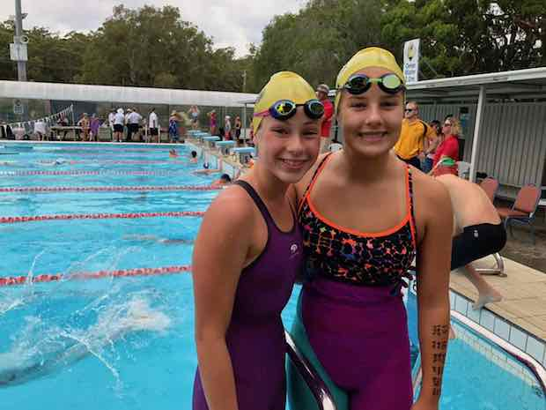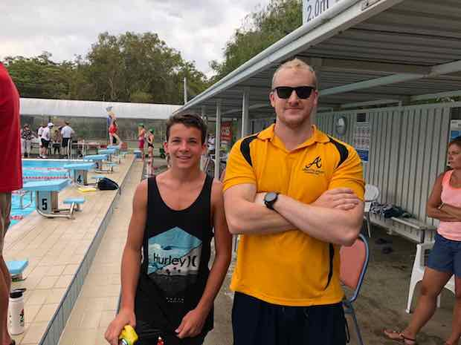
Swimming Australia www.swimming.org.au
Swimming Australia is the national governing body for competitive swimming in the Australia. As the national governing body, Swimming Australia is responsible for the conduct and administration of swimming in the Australia. In this capacity, Swimming Australia formulates the rules, implements policies and procedures, conducts national championships, disseminates safety and sports medicine information and selects the athletes to represent the Australia in international competition.
There are numerous benefits to joining our club and you will therefore become a member of Swimming Australia too - www.swimming.org.au/Home/Swimmer-HQ/Squad-Swimmers/Annual-Member-Benefits.aspx
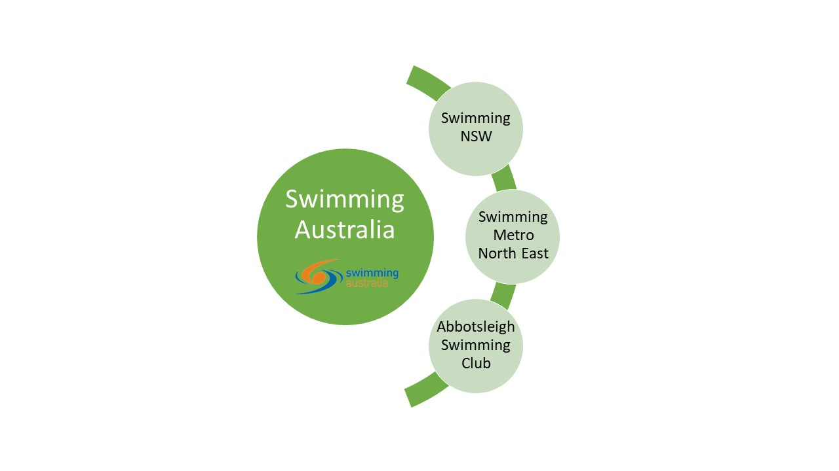
Swimming NSW www.nsw.swimming.org.au
Swimming NSW currently maintains a membership of over 37,000 members across 13 affiliated Areas and over 380 Clubs. Abbotsleigh Swimming Club is one of these clubs and we are in Metro North East Area.

Swimming Metro North East www.smne.org.au
Swimming Metro North East is the local arm of Swimming NSW and Swimming Australia. Membership consists of about 20 clubs and 1,000 competitive swimmers. Carnivals are run, development programs instigated, and officials trained. Additionally, there is coach development support, coordination of activities as well as investing around $60,000 annually in swimming in the local area. SMNE is entirely volunteer run and is led by a committee which meets monthly. Everything in SMNE happens through the fantastic support of our clubs, parents, coaches and other volunteers.

Abbotsleigh Swimming Club
We are based at the Abbotsleigh School Aquatic Centre in Wahroonga on Sydney’s north shore. Swimmers train in our 8 lane 25m indoor facility, and nearby in the 50m indoor Knox pool and 50m indoor Pymble Ladies’ College pool.
The primary source of information for matters concerning Abbotsleigh Swimming club is via the club website – www.abbotsleighswimclub.org.au
Swimmers are coached by Abbotsleigh School Aquatic Centre staff and coaching fees are paid directly to them. Abbotsleigh Swimming Club is however a separate organization. Anybody is eligible to join the Abbotsleigh Swimming Club – boys and girls! We cater for a wide variety of swimmers from those just out of “learn to swim” through to an elite level. All Mini Marlins, Junior Challenge, White, Black and Gold Squad Members are required to join the club, and we encourage any swimmers who would like to experience competition to consider joining. The easiest way to join is via – www.abbotsleighswimclub.org.au/membership
If your daughter/son is totally new to competitive swimming a good resource for information is www.abbotsleighswimclub.org.au/new-to-competitive-swimming
Club nights are held throughout the year and club members regularly attend external swimming meets. The Abbotsleigh Swimming Club is a not for profit organisation run by a voluntary management committee and relies on the assistance of parents to provide club racing and support to our swimmers. In Information on our fantastic coaches can be found at www.abbotsleighswimclub.org.au/about-us/

Members are expected to purchase club apparel. At a minimum this includes a club yellow swimming cap (sold at front desk) as well a club shirt. All clothing is sold online through a club affiliate - http://www.xpresspromotion.net.au/water-sports/abbotsleigh-swimming-club
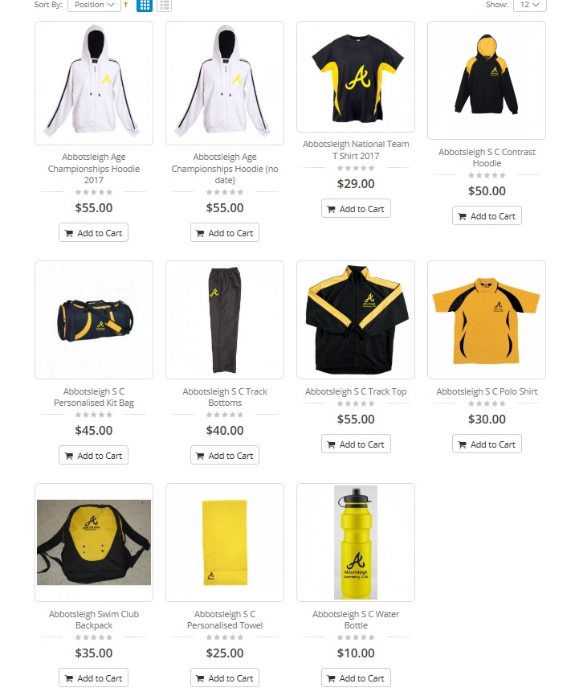

*** Prices and items subject to change ***

Some additional information can be also found via the Abbotsleigh school website - http://www.abbotsleigh.nsw.edu.au/community/aquatic-centre/schedule-updates
Adults swimming times and aqua aerobics are some of the additional activities that occur at the pool.
A limited number of dedicated Aquatic Centre parking spaces are available in the underground car park accessed via Gate 1A. At certain times a code is required to exit the carpark. This code can be found at the foyer of the Aquatic Centre.
Street parking is also available for the Aquatic Centre in The Glade. All pedestrian access to the Aquatic Centre should be via The Glade walkway.

SWIMMING: THE SPORT
The Skills
The five competitive disciplines are freestyle, backstroke, breaststroke, butterfly, and individual medley.
The Competition
Each swim offers a variety of events and distances, depending on the age group.
In freestyle events, the competitor may swim any stroke. The stroke most commonly used is the crawl, which is characterized by the alternate overhand motion of the arms and an alternating (up-and-down) flutter kick. On turns, some part of the swimmer must touch the wall. Most swimmers do a flip turn and touch the wall with their feet.
Backstroke consists of an alternating motion of the arms with a flutter kick while on the back. On turns, swimmers may rotate to the stomach and perform a flip turn with some part of the swimmer touching the wall.
The breaststroke, which is the oldest stroke dating back hundreds of years, requires simultaneous movements of the arms on the same horizontal plane. The hands are pressed out front in front of the breast in a heart shaped pattern and recovered under or on the surface of the water. The kick is a simultaneous somewhat circular motion similar to the action of a frog. On turns and at the finish, the swimmer must touch the wall with both hands simultaneously at, above or below the water surface.
Some consider the butterfly to be the most beautiful of the strokes. It features a simultaneous over water recovery of the arms combined with an undulating dolphin kick. In the kick, the swimmer must keep both legs together and may not flutter, scissors or use the breaststroke kick. (The butterfly is the newest stroke and was developed in the early 1950s as a variation of the breaststroke. It became an Olympic stroke in 1956 in Melbourne, Australia.)
The individual medley, commonly referred to as the I.M. features all four strokes. In the I.M., the swimmer begins with the butterfly, then changes after one-fourth of the race to backstroke, then breaststroke and finally freestyle. Some people feel that being the best in the I.M. means you are the best swimmer.
In the medley relay, all four strokes are swum. The first swimmer swims backstroke, the second breaststroke, the third butterfly, and the final swimmer anchors the relay with freestyle.
The freestyle relay events consist of four freestylers, each swimming one quarter of the total distance of the event.
Starts, turns and finishes. Many races are won or lost by the swimmer’s performance in the start, turn or finish. At the start, the swimmer is called to the starting position by the starter who visually checks that all swimmers are motionless. When all swimmers are set, the gun or starting horn is sounded to start the race. If the starter feels that one of the swimmers has moved, left early or gotten an unfair advantage, the guilty swimmer may be disqualified after the race for a false start. Under Swimming Australia rules, one false start disqualifies the swimmer.

The Rules
The technical rules of swimming are designed to provide fair and equitable conditions of competition and to promote uniformity in the sport. Each swimming stroke has specific rules designed to ensure that no swimmer gets an unfair competitive advantage over another swimmer.
Trained officials observe the swimmer during each event to ensure compliance with these technical rules. If a swimmer commits an infraction of the rules, a disqualification will result. This means that the swimmer will not receive an official time and will not be eligible for an award in that event. A disqualification may result from actions such as not getting to the starting blocks on time, false starting, performing strokes in an illegal manner, or unsportsmanlike conduct.
Disqualifications are a result of technical rules violations. They include but are not limited to:
Freestyle: Walking on the bottom; pulling on the lane rope; not touching the wall on a turn; not competing the distance.
Backstroke: Too many pulls into the wall once a swimmer has turned passed the vertical on to the breast; turning onto the breast before touching the wall with the hand at the finish of the race.
Breaststroke: An illegal kick such as flutter (freestyle), dolphin (butterfly), or scissors (side stroke); shoulders not level; alternating movements of the arms; taking two arm strokes or two leg kicks while the head is under water; touching with only one hand at the turns or finish.
Butterfly: Alternating movements of the arms or legs; pushing the arms forward under instead of over the water surface (underwater recovery); a breaststroke style of kick; touching with only one hand at the turns or finish.
For specific language on any technical rules consult the Swimming Australia Rules and Regulations book. Violations of the rules are reported to the referee. The rules require that every reasonable effort be made to notify the swimmer or his coach of the reason for the disqualification. If your child is disqualified in an event, be supportive rather than critical. For beginning swimmers, a disqualification should be treated as a learning experience, not as a punishment. A disqualification alerts the swimmer and coach to what portions of the swimmer’s stroke need to be corrected. They should be considered in the same light as an incorrect answer in schoolwork - they point out areas that need further practice. Disqualifications are necessary to keep the competition fair and equitable for all competitors. A supportive attitude on the part of the official, coach, and parent can make a positive situation out of the disqualification.
The Course
Competition pools may be short course (25m), or long course (50m). The international standard (as used in the Olympics) is 50m. World records are accomplished in 25m and 50m pools. Swimming Australia maintains records for 25m and 50m.
Officials are present at all competitions to enforce the technical rules of swimming, so the competition is fair and equitable. Officials attend clinics, pass a written test and work meets before being certified. All parents are encouraged to get involved with some form of officiating.
Referee: Has overall authority and control of the competition; ensures that all the rules are followed; assigns and instructs all officials; decides all question relating to the conduct of the meet.
Timers: Operate timing devices (watches or semi-automatic timing systems) and record the time for the swimmer in their lane. Two to three timers are needed for each lane. This volunteer position offers an ideal opportunity for new parents to work at a swim meet.
Inspector of Turn Judges: Observe the swimmers from each end of the pool and ensure that the turns and finishes comply with the rules applicable to each stroke.
Starter: Assumes control of the swimmers from the Referee, directs them to “take your mark,” and sees to it that no swimmer is in motion prior to giving the start signal.
Stroke Judges: Observe the swimmers from both sides of the pool, walking abreast of the swimmers, to ensure that the rules relating to each stroke are being followed. The positions of Stroke Judge and Turn Judge may be combined into one position called the Stroke and Turn Judge.
Who Is a Volunteer?
A volunteer is a person who is willing to help perform any one of the necessary jobs in Swimming Australia and at Abbotsleigh Swimming Club. Your role as a volunteer is important to our sport. You can be actively involved in your child’s swimming program and can also be instrumental in strengthening swimming in the Australia. With a positive attitude and a willingness to lend a hand, you will also have a great impact on your child’s athletic environment and love of swimming. A few of the rewards of volunteering are meeting new people, making new friends and having that great feeling that you have helped an organization in which volunteers are the most important people.
Give volunteering a try. Any contribution you can make will be appreciated. Ask the coach of your team what you can do to help. He will appreciate the offer and put you in touch with appropriate people on your team that will place you in an area where your best skills are used to make the swimming experience joyful for everyone on the team. If your club has a booster organization, find out how to join.
Volunteer Jobs
There are unlimited opportunities to get involved and Abbotsleigh Swimming Club is always looking for enthusiastic volunteers.
Committee Board Member: At the Abbotsleigh Swimming Club, volunteers are needed to serve on the Club Committee Board of Directors as well as sub-committees.
Technical Official: TO’s are needed to ensure that swimming carnivals run correctly and on time. There are numerous roles that need to be filled. Accreditation for more senior roles is conducted through Swimming Metro North East. Further information at www.smne.org.au/volunteers-officials
Team Representative: Serve as the club representative or take on another volunteer role within the club, Metro North East, Swimming NSW or Swimming Australia.
Club Night Assistant: There are many ways to assist on club night ranging from time keeping through to cooking the BBQ and everything in between.
Event Time Keeper: If your son/daughter is a competitive swimmer they will be regularly involved in carnivals external to club competitions. There is an expectation that swimming clubs provide time keepers to assist in the running of the day’s events. Commonly parents will be rostered on for an hour or two to fulfil this duty.

Finding Balance
https://swimswam.com/4-tips-find-balance-swim-parent/
Swimming is a sport that requires balance: balance in the water in terms of body position, balance with academics and a social life, and balance for busy parents and a family life. Because of the demands of swimming, parents need to be engaged but not take over. Swimming requires a level of commitment from parents—as well as our swimmers.
Someone commented about the problems of “under parenting” in a recent article I wrote about how to avoid being a helicopter parent. I couldn’t agree more. I’ve seen parents who hover over their children constantly, but on the flip side, some aren’t involved or interested in their children’s education or sports. I remember one mom saying she couldn’t stand being at the pool and would drive off as soon as her child left the car. Needless to say, this child didn’t stick with swimming for long.
Here are four tips for finding the right balance between “helicoptering” and “under parenting:”

ONE
Does your child know you appreciate their hard work?
We can encourage our kids without taking over. We want our kids to enjoy swimming, take ownership and be intrinsically motivated. We can let our kids know we’re proud of them for their effort, not just a great performance. If you’re never around to watch them swim, your children’s hard work will go unnoticed and be undervalued. Show interest by asking a few questions about practice, like what did they like about it or who was there.

TWO
How do you volunteer?
Are you the parent who can be counted on to jump in and help wherever you’re needed? Or, are you the parent who disappears and has to be hunted down to fulfill a timing obligation? Our kids learn a lot from how we approach volunteering for the team. We’re modeling how to help out in our community—and at the same time, they’ll know we are enthusiastic about their sport.

THREE
Do you go to meets and enjoy them?
I’ve seen parents drop their kids off at meets and not go inside to watch their kids race. They use this time to get work done or run errands. I’ve also seen a swim mom or dad at meets but never their spouses. Other parents find rides for their kids and they’re never seen. Swim meets are a perfect place for balance. We don’t need to get so wrapped up and treat meets like they are life or death. Yet, we need to be cheering for our kids and let our swimmers know we love to watch them swim.

FOUR
Do you get your kids to practice consistently?
If swimming isn’t a priority for you or your family, then most likely swim attendance will be spotty. It’s the type of sport that isn’t easy if your kids aren’t consistent. Then, it’s tougher for them to improve and make progress—which is key for children to feel good about swimming. Also, if they’re frequently late or don’t go often, chances are their coaches will be frustrated or less enthusiastic. Children will know if it’s a hassle for their parents to get them to practice and it’s a task they’d rather avoid. In that case, it would be hard for any child to want to swim.
How do you find the right balance as a swim parent?

How to be an awesome swim parent!

http://www.yourswimlog.com/how-to-be-an-awesome-swim-parent/

The swim parent lifestyle is a soggy, herculean and often thankless one.
There are all of the early morning practices, the weekend-long swim meets, the fundraising, helping with the board, chaperoning, the fees, the carpooling, and the food, ohmagod, all the food.
And most importantly, there is the most fundamental and irreplaceable role you have as a swim parent: cheerleader and support staff to your little athlete.
I get a lot of emails from parents who want the best from their swimmers, for them to enjoy the process of improving, but are often unsure what to do. It’s an awkward two-step of wanting to encourage their kids to be better, but to be better without having to be necessarily pushed.
Some recent research on elite athletes have shown that top performers have parents (and coaches) who are supportive, but who still allow the young athletes to own their sport and subsequent performances.

With that in mind, here are some ideas on how to be an awesome swim parent:

1. Encourage accountability.
At the end of the day you want swimming to be your swimmer’s sport. Their thing. Let them take ownership of the sport by letting them have their own goals, and encourage them to evaluate and track their workouts to further instill a sense of control of their swimming. If they have their own reasons for swimming and showing up every day to work hard they are going to be more intrinsically motivated to stay (and succeed) in the sport.

2. Avoid over-identifying with your swimmer’s performance.
How they swim isn’t a reflection of you. Don’t fall down the over-identification trap where your child’s swim performance is a reflection of you, leading you to ignore how they feel about the sport and focusing on your feelings. Taking the burden for their swimming also removes accountability on your swimmer’s part. The more likely it’s their thing, the more likely they are to be successful.

3. It’s the process.
If they are getting better, and learning the process of mastering something they are learning and benefiting far more than just having a win-at-all-costs attitude. It’s what they do every day—mastering the process of becoming a better swimmer—that matters more than what they do at meet-time. A swimmer who is able to master the grind will always outperform an athlete who magically shows up at meet time.

4. Set the standard for how they should react.
I cringe when I see a parent who lacks emotional control at swim meets. You can see the discomfort of those nearby as well, as in, “Jeez buddy, it’s just a swim race.” These parents not only tend to end up bumping and spitting all over nearby parents and swimmers, but also provide a classic example of poor sportsmanship and set a low standard of self-control for their own swimmer to emulate.
It is contradictory and confusing for children to be told to have self-control, to stay calm and focused in moments of high pressure when their parent is screaming at the coach and losing their chlorinated mind from the stands.

At the end of the day you are your swimmer’s strongest role model. Not the swimmer on the Wheaties box.

5. Don’t mistake sacrifice for investment.
Swim parents are absolutely unbelievable in terms of sacrifice. They spend a metric ton of time, energy and money in helping the sport go round. From all of the time spent organizing fundraisers, driving back and forth to the pool, countless swim meets, hotel rooms, flights, and more we sacrifice a lot for our swimmers.

And so it’s tempting to have this sacrifice sometimes blur into a sense of investment, causing parents to expect measurable dividends of some sort (college scholarship, sponsorships, etc). Swimming (and sport in general) isn’t something that can and should be measured in terms of dollars and cents. The time spent in the pool now shouldn’t come with a balance sheet later. The gold medals they don’t win today still translate into healthy lifestyle choices they carry with them for life.

6. When issues come up with coach, address them privately and directly.
There will be times where as a swim parent we have questions or concerns regarding our kid’s swimming. Over the course of a swim career this is unavoidable. Maybe your swimmer hasn’t improved at all in a couple months and we’d like to know more about why this is. Or perhaps she is being held back a group. Or you have questions about the plan for the team.

Too often when a parent has an issue with coach they will sit in the stands gossiping and complaining to other parents, which does nothing but create a divisive environment for all involved.
Set a time to meet with the coach that you can talk distraction-free (blindsiding them on the way to their car after practice doesn’t count).

Undermining the coach, whether it’s giving contradictory technique and training instruction out of the water, only serves to confuse and put your little swimmer in a place where they have to choose between listening to you or coach when they are at practice. In ideal situations, parents parent, and coaches coach.

7. Let them unplug outside of the pool.
Swimming isn’t and shouldn’t be the only thing in anybody’s life. Once they leave the aquatic center in the morning or at night-time they should be able to leave it behind. Constantly having to rehash practice or meets in the car, at home, and over the dinner table is mentally exhausting. Have some perspective about where swimming truly ranks in the scheme of things. Being a great swimmer is cool, but being a young person with enough perspective to realize that it’s just a race or just one practice is even better.

8. The facilities don’t make the athlete.
It’s natural to want the absolute best for our swimmers. The best coaches, the best facilities, the best of everything. But removing all obstacles in their talent development ends up having an unintended consequence: an inability to deal with adversity later on in their careers. After all, having been robbed of the lessons, humility and resiliency that comes from adversity means that when it does finally happen these athletes have a hard time adjusting.

Being on a star-studded team doesn’t guarantee success. Just like how training out of a dark, cramped 22-yard pool doesn’t promote failure. The lessons and skills can be and are picked up in different environments and if anything, the “less than” athlete is going to be at an advantage when it comes to dealing with hardship.

9. Just be there for them.
More than anything, your little swimmer just wants you to be there for them.
To be a shoulder to cry on and to provide a moment of levity when they add time to their PB. To whisper words of encouragement when they are injured. To share the moment when they finally do succeed. Win or lose, all they really want to know is that their swimming, and by extension their identity, isn’t a prerequisite for you being there for them. Don’t make your love conditional on how they swim. All they want to know and feel is that first or last, whether they are world record holder or local sharks-and-minnows champ, that you will love ’em.

GLOSSARY OF SWIMMING TERMS
Age Group Swimming The program through which Swimming Australia provides fair and open competition for its younger members. It is designed to encourage maximum participation, provide an educational experience, enhance physical and mental conditioning, and develop a rich base of swimming talent. Nationally recognized age groups are 10 and under, 11-12, 13-14, 15-16, and 17-18. Local meets may also include events for 8 and under and single age categories.
Block The starting platform.
Bulkhead A moveable wall, constructed to divide a pool into different courses, such as a 50m pool into two 25m courses.
Circle Swimming Performed by staying to the left of the black line when swimming in a lane to enable more swimmers to safely swim in each lane.
Coach A person who teaches and trains athletes in the sport of swimming.
Code of Conduct An agreement signed by swimmers, coaches and parents stating that they will abide by certain behavioural guidelines.
DQ Disqualification. This occurs when a swimmer has committed an infraction of some kind (e.g. freestyle kick in butterfly.) A disqualified swimmer is not eligible to receive awards, nor can the time be used as an official time.
Drill A teaching exercise involving a portion of a stroke which is used to improve technique.
Dryland Training Training done out of the water that aids and enhances swimming performance; usually includes stretching and calisthenics (also see weight training).
Entry Form Form on which a swimmer enters a competition. Usually includes club and swimmer name, Swimming Australia number, age sex, event numbers, event names and entry times. Often this is submitted online.
False Start Occurs when a swimmer is moving before the start is sounded. In Swimming Australia, one false start will result in disqualification.
Final The championship heat of an event in which the top swimmers from the preliminaries compete. Usually only occurs for State and National events.
Finish The final phase of the race; the touch at the end of the race.
Flags Backstroke flags placed 5 meters (long and short course meters), from the end of the pool. The flags enable backstrokers to execute a backstroke turn safely and more efficiently.
Goal A specific skill or time achievement a swimmer sets and strives for. Can be short or long term.
Gutter The area along the edge of the pool in which water overflows during a race and is circulated through the filtration system.
I.M. Short for Individual Medley. An event in which the swimmer uses all four strokes in the following order: butterfly, backstroke, breaststroke, freestyle.
Lap Counter A set of display numbers used to keep track of laps during a distance race longer than 500 yards. (Also, the title given to the person who counts for the swimmer, stationed at the opposite end from the start.)
Long Course A pool 50min length. Swimming Australia conducts most of its summer competition in long course pools.
Meet Competition designed to be a learning experience. By implementing what has been learned in practice, the swimmer races against the clock to determine improvement.
Negative Split Swimming the second half of the race equal to or faster than the first half.
Technical Official (TO) A judge on the deck of the pool at a sanctioned competition who enforces Swimming Australia rules. There are stroke and turn judges, administrative officials, starters, timers and referees.
Open Water Swims A freestyle conducted in a natural body of water, such as a lake, river or ocean.
Pace Clock Large clock with a large second hand and a smaller minute hand, used to check pace or maintain intervals in practice; may also be digital.
Prelims Short for preliminaries. Also called Heats or Trials. Those races in which swimmers qualify for the championship, consolation finals or semi-finals.
Qualifying time Time necessary to compete in a particular event and/or competition.
Relay An event in which four swimmers compete together as a team to achieve one time.
Safety The condition of being safe. Safety procedures are designed to prevent accidents.
Scratch To withdraw from an event prior to it being held in a competition.
Short Course A pool 25m in length. Swimming Australia conducts most of its winter competition in short course metres.
Split A time recorded from the official start to the completion of an intermediate distance within a longer event. Also the time for one of the four individuals in a relay. Under certain conditions, splits may also be used as official times, for example, the lead off swim in a relay, or the lead off portion of an event.
Sprint Describes the shorter events (50 and 100). In training, to swim as fast as possible for a short distance.
Streamline The position used by swimmers when starting or pushing off the walls designed to reduce water resistance.
Taper The final preparation phase, sometimes referred to as ‘rest’. The slow gradual reduction of workloads and intensities in preparation for season ending competition.
Touch Pad A large touch sensitive board at the end of each lane where a swimmer’s finish is registered and sent electronically to the timing system.
Swimming Australia Registration Number A number assigned to a swimmer upon joining Swimming Australia.
Warm Down Low intensity swimming used by swimmers after a race or main practice set to rid the body of excess lactic acid and to gradually reduce heart rate and respiration.
Warm Up Low intensity swimming used by swimmers prior to a main practice set or race to get muscles loose and warm. Warm up gradually increases heart rate, respiration and helps to prevent injury.
Stop Watches Stop watches used to time swimmers during a competition. When totally automatic timing equipment is used, watches serve as a back-up method.

